
City Solicitor (& Monitoring Officer)
Directorate: Resources and Transformation Reporting to: Executive Director / Chief Executive
Grade: Local Scale Band B Salary: £106,088 – 118,818
Location: Flexible Hours: 36.00

About the role
- To be the chief legal adviser for Salford City Council providing oversight of the most significant legal matters for the Council and advising the Elected Mayor, Chief Executive, Corporate Management Team, and Cabinet and political groups, ensuring all decisions are lawful and fair.
- Ensures that lawful and transparent decision making and governance arrangements are in place, providing continuous development and leadership of governance arrangements and scrutiny within the council.
- Contribute to the corporate management of the council, in particular through membership of the corporate management team.
- To be the Council’s Monitoring Officer with statutory responsibility under s.5 of the Local Government and Housing Act 1989 and responsibility for the effective operation of the Councillors’ Code of Conduct including decision taking on complaints. Specific duties of the Statutory Monitoring Officer are detailed in the separate ‘Functions of the Monitoring Officer’ document.
- Robust oversight of the client side management of the shared legal service with Manchester City Council ensuring robust performance measures, monitoring and reporting are in place.
- Responsibility for the legal and governance division which includes Democratic Services, Electoral Services, Registrars, Information Governance and Client management for the Shared Legal service with Manchester City Council.
- Lead officer for liaison with and oversight of the Coroners’ service provided by Bolton Council.
- Holds the responsibility of the Deputy Returning Officer for elections and the Deputy Electoral Registration Officer.
- Leads, inspires and provides senior management support to employees within the division, motivating and supporting them to attain the highest professional standards, skills, knowledge, attributes and competencies required to fulfil their duties.
- Works closely with elected members and senior leaders to ensure the effective delivery of services in line with the City Mayor’s and Council priorities ensuring lawfulness and probity.
- Provides visible, strategic leadership as part of the council’s senior leadership team and within the Resources and Transformation Directorate, and embodies the leadership behaviours as described in the #LeadingSalford leadership framework.
- Ensures inclusive and effective people management across the division, encouraging a positive employee relations climate and active employee and collective engagement through the trade unions.
- Ensures appropriate arrangements are in place for preparing and monitoring budgets and associated income for the division and adheres to the standing orders and financial arrangements of the Council.
- Ensures the Council meets its legal and statutory obligations for the service’s areas of responsibility
- Leads a people centred and values-based culture where people are encouraged to learn and develop, inspiring employees and providing senior management support within the division, motivating and supporting all employees to achieve their full potential.
- Through personal example, commitment and action develop an inclusive, supportive and constructive environment where everyone is treated with dignity and respect and diversity is valued in the workplace, in service delivery and communications.
- Undertakes duties as part of the Emergency Planning and business continuity rota.

Key outcomes
- As the Council’s most senior legal advisor, support the Council, City Mayor, elected members, the Chief Executive, Corporate Management Team and other key organisational decision makers in order to deliver Council priorities in accordance with all legal requirements.
- Acts as the Deputy Returning Officer and Deputy Electoral Registration Officer ,as appropriate and, in such roles, ensures that the register of electors and elections are conducted in accordance with statutory requirements.
- Maintains technical competence in all areas of law and the democratic process and protocol to provide clear professional advice to political leaders and senior colleagues including providing challenge where legal and professional standards are not being upheld.
- Monitors and reports on legal developments and trends relevant to the work of the Council and works with the Shared legal service to coordinate action in response.
- Maintains a detailed knowledge and understanding of the law as it relates to local authorities and specific matters relating to an elected mayoral model of governance.
- Contributes to the setting, monitoring and meeting of service, cross service and corporate strategic intents, plus targets and objectives, to deliver effective, efficient and business focused strategic solutions, working in partnership with management teams.
- Leads, builds and manages positive, constructive productive relationships across the directorate, the council and its strategic partners, stakeholders and local communities.
- Ensures the Council’s Constitution and Schemes of Delegation are up to date and fit for purpose and decisions are taken which are consistent with those.
- Develops effective approaches to corporate governance through a quality assurance framework including the provision of high-quality monitoring, support, challenge and the development of collaborative approaches with partners and other agencies.
- Working jointly with the Head of Audit to ensure that the annual governance statement is produced.
- Manages, on behalf of the Chief Executive, complaints made to the Local Government and Health Services Ombudsman.
- Supports the implementation of digital transformation to deliver the most effective ways of working.
- Leads a people centred and values-based culture where people are encouraged to learn and develop, inspiring employees and providing senior management support within the division, motivating and supporting all employees to achieve their full potential.
- Develops and maintains a workforce with the capacity and capability to deliver on the agenda for the division and develops a culture that promotes innovation and creativity in service transformation and delivery.
- Plans, monitors and reviews the service area budget, providing ongoing scrutiny to ensure that services are provided within budget and show value for money and are effectively managed.
- Contributes to the directorate business plan and develops divisional work programmes that are aligned with the Council’s political priorities.
- Builds effective networks at senior levels and uses these to lead and influence professional groups to secure cross-system change

What we need from you
- Professional credibility and capability through proven strategic leadership experience combined with expert and specialist knowledge of public sector legal and governance matters.
- The ability to discharge the statutory responsibilities of the Monitoring Officer with a positive determination and in a manner that enhances the overall reputation of the Council.
- Be solutions focussed within the law and legal frameworks when advising the senior officer and elected member/ political leadership of the Council to reach desired outcomes and deliver priorities.
- Successful experience of creating and maintaining effective and influential partnerships, working collaboratively at a senior level.
- Politically astute with an understanding of the elected mayoral model of governance.
- Skilled communicator who communicates with clarity, conviction, and enthusiasm both verbally and in written reports and is able to demonstrate integrity, create rapport and build trust and confidence.
- Ability to translate complex ideas and information into meaningful and ‘user-friendly’ information; ‘tells the story’ to bring people along and ensure all audiences understand the key messages.
- Understand and works within the bigger picture and broader context and is able to translate overarching plans to a local setting.
- Having a high level of intellectual rigour, negotiation, and motivational skills, plus flexibility.
- Working to high standards, setting challenging goals that are focused on outcomes, not activities and drives for continuous improvement.
- Being open to learning and sharing your knowledge and skills with others; providing coaching and support to others to help them achieve their objectives and potential including appropriate support and training to elected members to help them to understand and fulfil their roles.
- Model and demonstrate the Council’s values and leadership behaviours, creating a shared purpose and positive permission culture that enables people to thrive through development, involvement and well-being.
- Technical requirements:
  - Be a solicitor or barrister holding relevant certificate to practice.
  - Have a detailed knowledge and understanding of the law as it relates to local authorities.
  - Be technically competent in all relevant areas of law and governance to be able to provide clear professional advice to political leaders and senior colleagues including the ability to challenge where legal and professional standards and duties are not being upheld.
  - Evidence of ongoing professional development
  - Substantial experience of successful leadership at a senior management level in a legal role within a large and complex organisation in the private or public sector.
  - Ideally experience in acting as a Local Authority Monitoring Officer or Deputy Monitoring Officer

What we can offer you
Your ongoing professional development and success in your role is important to us, and that is why we provide a variety of learning and development opportunities. Within the sections below you will find development options tailored to you which will enable you to further develop your existing skills and learn new ones at a pace that suits you best. If you are joining us new, your development will form part of ongoing discussions with your manager. If you are an existing employee, you should use your Personal Development Reviews to discuss your development with your manager and create your development journey. It’s important you also take full advantage of any informal learning available to you during the course of your work.
- Developing your leadership skills
We want to equip our leaders with the knowledge, skills and behaviours outlined in our #LeadingSalford behaviour framework. Our aim is to support you to lead highly engaged, motivated teams in today’s rapidly changing environment. We provide a range of core master classes designed to help you meet the expectations that we have of our Salford leaders. In addition, we also provide support with the essentials including our Management Essentials programme, Health and Wellbeing at Work, Strengths-Based Conversations, and Financial Skills for Non-Financial Managers.
- Online learning
Develop your knowledge across a wide range of areas through our Me-Learning platform, with over 200 free courses to choose from. To have the best possible start and comply with current legislation, you must complete the following modules: Welcome to Salford, Health and Safety in the Office, GDPR, Equality Essentials, Safeguarding Children and Adults, and Safer Recruitment. You may also benefit from a variety of courses in categories such as Business Skills, IT and Project Management which are available to learn at your own convenience and pace.
- Professional development
Gain role specific skills and time to learn through a wide range of development opportunities. Learn whilst working and get support towards your qualification through an apprenticeship standard. Access professional development ranging from entry level to master’s type qualifications, including achieving a role appropriate qualification. Details can be found on the Institute of apprenticeships website.
- A digital organisation

Developing your digital skills
Our ambition is to ensure that our workforce have the right level of digital capabilities needed to be successful. Whatever your current digital abilities are, we can provide development ranging from essential workplace skills to specialist workplace skills delivered through our Digital Skills Academy using both self-directed and guided learning opportunities to enable you to develop. Additionally, you can access free online courses through the iDea website.

Our vision and priorities

Our vision
The Council has a vision is to create 'A fairer, greener, healthier and more inclusive Salford'.
To help us achieve this vision we have identified some key priorities to tackle the problems people in Salford are currently facing detailed within our Corporate Plan
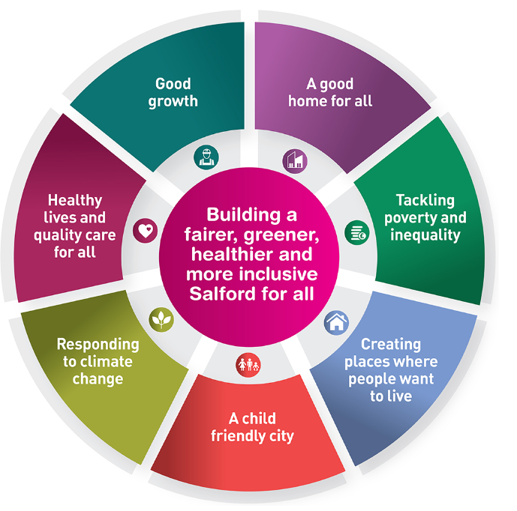

Our organisation’s values
To achieve this vision, we have a strong set of values. Pride, Passion, People and Personal Responsibility which capture the spirit and ambition of the city and inform the way we operate. They influence our choices, behaviours and how we make decisions and do things. Living the values day in and day out creates a supportive environment which allows us ‘to be the best we can be’ and achieve our vision. To explore these in more detail click on the visual.


Our leadership behaviours

As a values-based leader you will:
- Model the values and embed them into the way your team delivers services.
- Hold people accountable for demonstrating the values.
- Respect and care for others, treating everyone fairly, valuing, and welcoming diversity, respecting people’s identity, listening and acting on the things people say to enable everyone to achieve their full potential.
- Be honest, taking responsibility for your actions and decisions.
- Use resources that you are trusted with wisely .

To lead others you will:
- Listen to understand, not to defend.
- Give people the freedom to use their initiative.
- Provide opportunities for people to discuss and solve problems and issues – focussed on learning not blame.
- Regularly provide coaching and support to others to help them achieve their objectives and potential.
- Appreciate and build on people’s strengths.
- Motivate, engage, encourage and inspire others in order to be the best they can be.
- Build lasting productive relationships with residents, partners and elected officials.

To lead outcomes you will:
- Be visible, inject pace, vigour, and purpose.
- Expect high standards; mediocrity is not acceptable.
- Take an evidence and whole system approach in making decisions.
- Maximise technology and models to deliver quicker, easier, better services.
- Have a digital mindset, fully utilising digital systems, and solutions to deliver services efficiently and effectively.
- Set context and challenging goals that will motivate people to take ownership, maximise performance, and develop.

To build and communicate a vision for the future you will:
- Be optimistic and ambitious for the city and its people, helping others to understand the need to change how we do things.
- Build strong collaborative relationships to find creative ways to make services more sustainable and flexible.
- Recognise and value the strengths of people and places, taking a strengths-based approach to make the most of opportunities.
- Support people through change, in undertaking new things, and taking risks.
- Take a place and whole system approach in designing, delivering, and leading services developing solutions with our partners.
- Ensure inclusion is integral to service delivery and organisational performance and develop a resilient, diverse workforce who reflect the increasing diversity of our city.
- Be optimistic and ambitious for the city and its people, helping others to understand the need to transform public services.

Application guidance
We are a values-based organisation so reflecting our values or a values-based approach in your evidence will support your application.
The different sections of this role profile are there to give you an understanding of the purpose of the role. The ‘what we need from you’ section outlines the minimum criteria you will need to meet within your application.

