ROYAL BOROUGH OF WINDSOR AND MAIDENHEAD

Job Accountabilities

Job Title:  Principal Planning Officer | Job number:  CP0121
Directorate :  Place | Service Area:  Planning- Development Management

JOB PURPOSE
The role would deal with a wide range of applications, pre-application enquiries and appeals, focussing on major and strategic applications. The role would include presenting items to planning committee and acting as the Council witness in Hearings and Public Inquiries. Principal Planners would be the lead officer for our most significant schemes and deputise for the Team Leaders including making delegated decisions and mentoring junior staff.

JOB ACCOUNTABILITIES
Service delivery accountabilities

Ability to communicate effectively both verbally, including developer and stakeholder meetings, presenting at planning committee and Inquiries, and in writing reports, statements and correspondence.
The ability to accurately read and interpret maps, plans and technical studies
Ability to absorb, assess and analyse large amounts of complex information/evidence and present coherent reports with well-reasoned planning balance and recommendations
Up to date knowledge of Planning legislation, policy and case law
Managing, negotiating, assessing and forming recommendations on large and complex planning applications, s106s and appeals. Including managing, communicating, and negotiating between consultees and other stakeholders.
Supervising/managing members of staff
You will be expected to effectively manage your time and workload; be customer focused; be proactive and responsive to delivering a quality service.

Standard accountabilities/responsibilities that apply to all council staff or specific groups are set out in the Employee Handbook, these include:
- Corporate management
- Information governance compliance
- Whistleblowing
- General Safeguarding Statement
- Project and work management
- Working in a team
- Risk management including Health & Safety
- Business continuity
- Equality of Opportunity
- Our corporate values
- Budget management
- Specific responsibilities for managers.

The handbook can be viewed here.

Local operating procedures and specific activities/tasks will be supplied by the service.

POSITION WITHIN SERVICE STRUCTURE
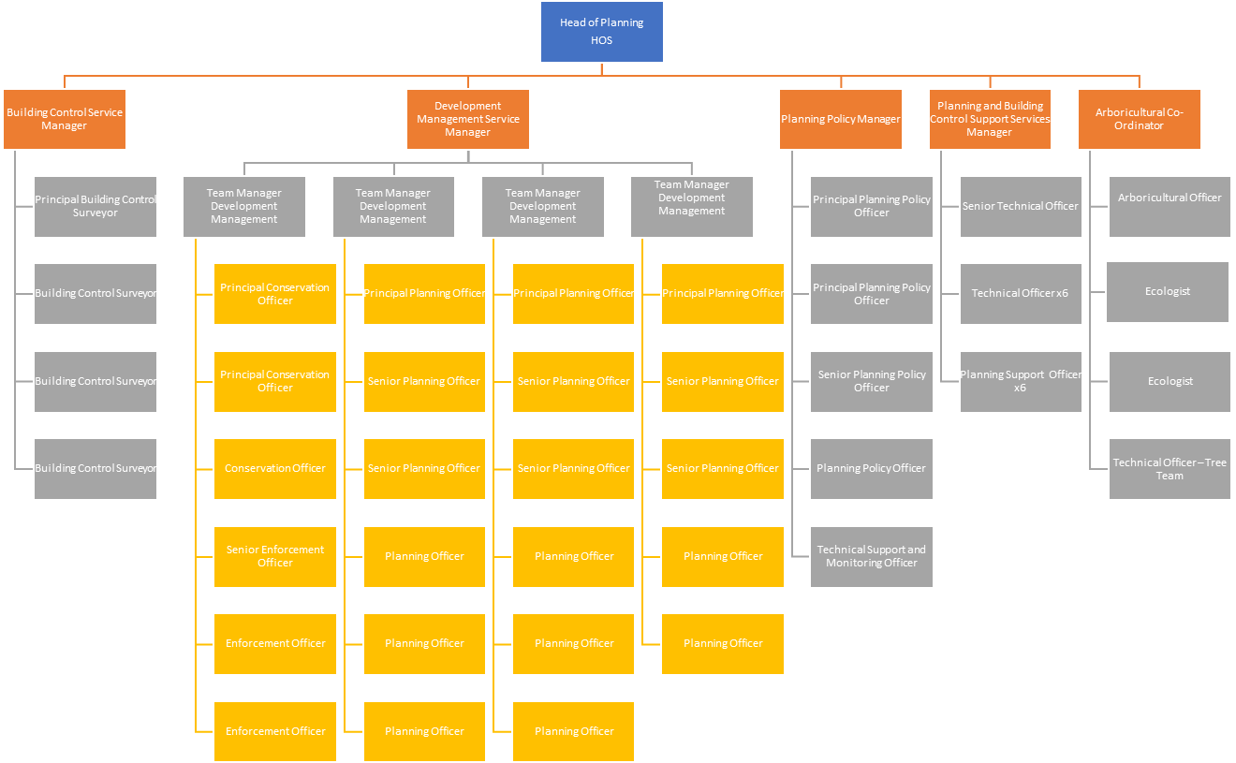

Person specification

Key Criteria | Essential | Desirable | How assessed
Qualifications and training | Degree in Town Planning or equivalent and membership of the Royal Town Planning Institute with at least 5 years relevant post qualification experience. |  | Application form
Job  Competence summary  (knowledge, skills, abilities, experience) | Up to date knowledge of planning law and handled a wide range of all types of planning applications.  Experience in managing planning appeals of all types.  Experience in negotiating complex section 106 agreements and an understanding of how CIL operates.  Experienced in presenting to Planning committee and attending other public meetings to represent the local planning authority.  Proven track record in managing own performance to meet the Government’s PS1 and PS2 targets.  To be able to maintain a principal planning professional role both within the Council and to external agencies and organisations within the code of conduct of the Royal Town Planning Institute.  Ability to implement successful resource management to enable the delivery and measurement of cost effective and high-quality services.  Enthusiastic self starter who can equally work as part of a team and demonstrate good commitment to the role. | Significant appeal experience relating to complex cases involving long inquiries.  Experience of working with CIL.  Supervision and coaching of junior staff.  Signing off delegated decisions.  Track record of resource management and innovation in planning.  Ability to write policies and procedures to improve service delivery. | Application form/interview/test.
Other requirements  (eg unsocial hours working, driving licence, fit to drive Council vehicle etc) | Access to own car and holds a cleaning driving licence.  Attendance at evening meetings for planning committee on a regular basis.
Politically restricted post

Yes

DBS check

No

