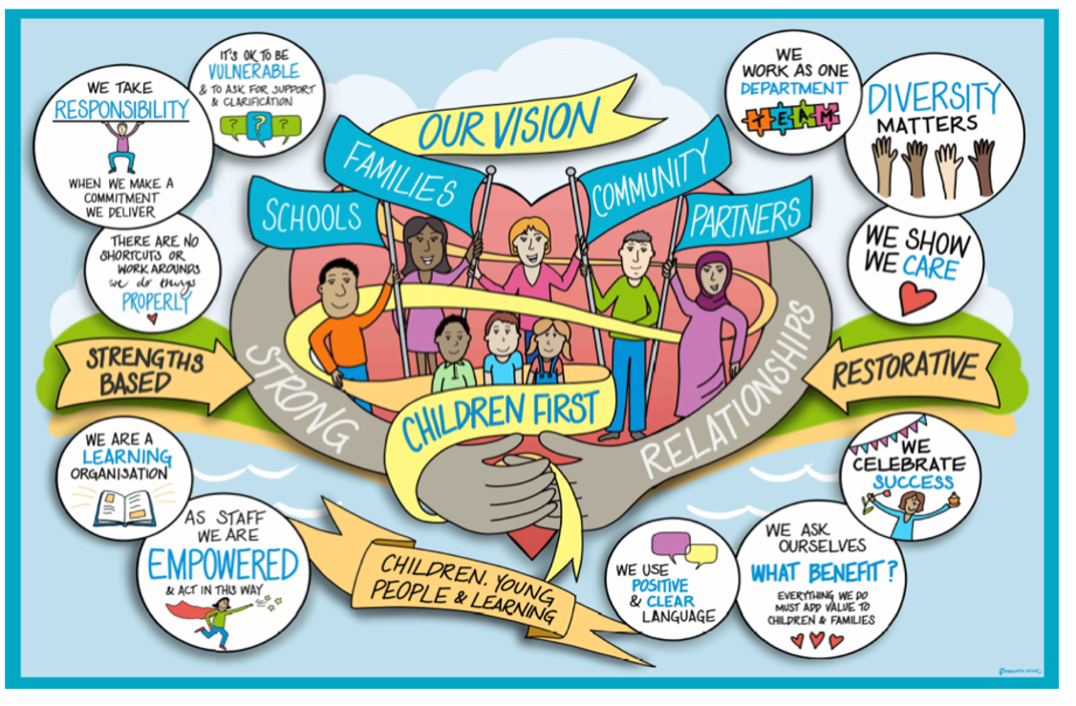

Children, Young People & Learning Department (DRAFT)

Workforce Development Plan

2024-26

# Contents

Contents 2

Introduction 3

Context and Ambitions 3

Monitoring our progress and improving 4

Children, Young People & Learning Workforce Development Plan 4

Workforce Priorities 5

Theme 1. Developing our Leaders and Managers 5

Theme 2: Wellbeing and Ways of Working 6

Theme 3: Learning and Development 7

Theme 4: Resourcing and Capacity 8

Underpinning Theme: Inclusion, Dignity and Respect 9

# Introduction

We recognise that without the support, drive, and commitment of our workforce our aim of achieving continuously improving services to children and families will not be possible. To continuously improve our Children’s Services, we must invest in and value the staff that work for us. We recognise that our staff cannot deliver great outcomes for children and families unless they work in an environment that enables them to thrive and to feel safe and secure in their practice. To achieve our vision for the children, young people, and their families, it is important that staff are at the centre of what we do too.

Our Workforce Development Plan sets out our commitments to enable this. This is supported with the creation of action plans for the coming year, and swift intervention plans where particular challenges are anticipated or identified.

# Context and Ambitions

The council has put in place the foundations to deliver the best service for our children and young people. We know that there is still more to do across our department to create an integrated and cohesive service that fully meets the needs of all vulnerable children in West Sussex. Our approach remains totally centred on putting children first and achieving the greatest beneficial impact for vulnerable children and families in line with the principles of the Family Safeguarding Model.

Our journey of improvement continues in exceptionally challenging circumstances. National pressures such as adjusting to the post-Covid world, the cost-of-living crisis, and the recognised fragility of some children’s mental health are all strongly present in West Sussex and have significant implications for increased demand. In this context, we believe that the task of leaders and managers is to create an environment wherein our practitioners can thrive, and to provide them with the leadership and motivation to support the best outcomes for children and families.

We recognise that national recruitment difficulties in certain professions and service areas is a challenge for our ongoing improvement. This is a challenge impacting local authorities across the country, and we wish West Sussex to remain competitive as an employer of choice. We recognise the importance of keeping vacancies gaps low across all services to ensure manageable workloads, provide space and time for learning and development, reflective practice, and to optimise time spent with children, families, and partners. We continue to keep a focus on recruiting and retaining staff through planning and acting with wholehearted efforts and creativity.

Overall, there are good indications of improved performance across the Directorate, but we recognise that to sustain and enhance these, we must maintain our skilled and motivated staff cohorts. Key to this is our aim to bring Education, Schools, and Social Care functions more closely together for the achievement of better outcomes for children and families.

Our aim is to create the conditions for good practice and collaboration to flourish and to create opportunities for our workforce to grow and develop. We recognise we must continue to prioritise:

* Stability in the workplace
* Professional and inclusive people management practices
* Support for continuous skills and knowledge development
* Empowerment and inspiration
* A reflective learning environment

## Monitoring our progress and improving

We regularly monitor key measures regarding our working environment. We use staff survey data and exit interviews to understand how staff feel about their work, retention data to understand capacity, and sickness absence information to understand the wellbeing of our workforce. We use this data to inform reviews of our workforce development plan and to inform annual action planning.

## Children, Young People & Learning Workforce Development Plan

Our workforce development plan identifies the specific interventions and actions that will be taken within the department in support of our ongoing continuous improvement priorities. An annual action plan sets out planned activities for each aspect of the workforce development plan. Our work is focussed around four key themes, and we commit to promoting and enabling inclusion, dignity, and respect in everything we do.

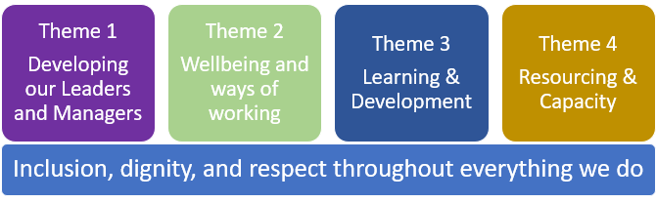

Our work under each of the themes and our work to promoting inclusion, dignity, and respect, will create the workplace we need for our workforce:

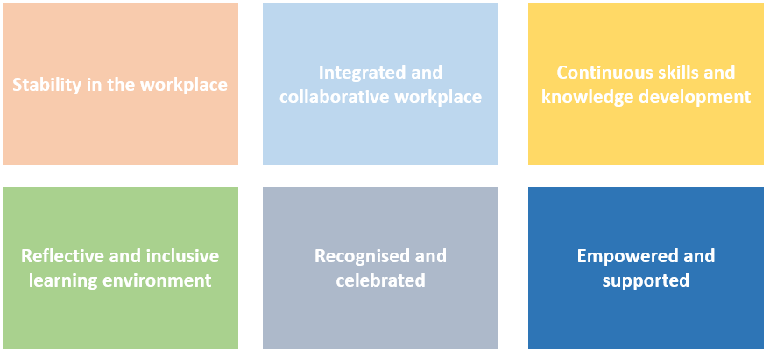

# Workforce Priorities

## Theme 1. Developing our Leaders and Managers

We expect our leaders and managers to model effective leadership behaviours, be visible and approachable, and apply professional and inclusive people management practices that inspire staff and support and empower them to develop and perform to their potential.

Key to our approach is creating a workplace that is based on collaborative and inclusive leadership, management, and problem solving. The priority of our leaders and managers is to create a sense of one service which is connected by a common purpose of putting children first, and for creating a psychologically safe environment where our dedicated practitioners can reflect, learn, and thrive to support the best outcomes for children and families.

Our leadership and management commitments are summarised as follows:

* We take accountability and adopt restorative approaches with our teams.
* We are visible role models coaching our teams to reach their potential.
* We enable innovation and continuous development.
* We enable safe and supported practice.
* We listen to our staff and act on their concerns.
* We value each other and our teams and celebrate achievements.

### Our current focus

We have developed a methodology for problem solving as a ‘quality circle’ where staff, managers, and partners work collaboratively to share and address challenges and barriers to achieving practice improvement. This approach focuses on integrating our Children First vision in everything we do, and is encouraging and supporting staff, managers, and partners to take control, accountability, and action for continuous practice improvement. The methodology is the basis for collaboration and problem solving across all our leaders, managers, and services within the department.

A Management Academy linked to WSCC Leadership Academy has been developed. The Academy provides the basis for consistent development planning for all leaders and managers across the department providing easy access to the resources they need, and clarity on expectations in standards, professionalism, practice, and inclusion. The Academy will provide development for aspiring team managers, service managers, and heads of service to support career development and planning.

## 

## Theme 2: Wellbeing and Ways of Working

We recognise the importance of supporting wellbeing in a context of change and improvement in maintaining resilience, engagement, and reducing ill health. We need to ensure all staff work within a supportive working environment so they can maintain wellbeing and resilience.

We recognise that job design, ways of working, and resourcing models will enable our staff to maximise the time spent on the most important and value add parts of their roles, while also achieving manageable workloads that optimise time spent with children and families. We will promote psychological safety and inclusion and champion the diversity of our workforce so that the contribution of every colleague is recognised and valued.

Our principles are summarised as follows:

* Mental and physical wellbeing is prioritised and supported.
* Workloads support wellbeing and impactful work with children, families, and partner agencies.
* Ways of working, systems, capacity enables manageable workloads.

### Our current focus

We regularly review staff survey responses, focus groups, and the social worker health check to ensure the voice of our workforce informs our action planning.

We are working towards optimising the way our systems and processes enable efficient ways of working across the department. As part of the review of our Business Services function, we are ensuring administration support is aligned to teams, and that capacity is focussed on the most impactful activities. Our improvement work includes projects aiming to ensure our IT Systems (for example case management systems) and the availability of equipment enables efficient and mobile working across the department.

We recognise the unique nature of the work undertaken in the department and we look to promote mental and physical wellbeing and self-care through joint working between service leaders and HR & OD. Excellent line management practices and reflective supervision/performance development will continue to be a priority. Wellbeing is further supported through team meetings and 121s to maintain focus on emotional wellbeing, reflective practice, and use of resources provided through the Council’s Wellbeing Hub. We will monitor wellbeing support within the service to ensure the provision meets the needs of our staff in key areas.

## Theme 3: Learning and Development

Key to achieving the improvements we aspire to, is ensuring that the workforce has the right knowledge and skills, and that practitioners have access to the right qualifications and development. We want all staff to feel that they can achieve their aspirations within the department, and that there are clear pathways for professional development and career development.

Our Children’s Social Care, Children’s Residential, Early Help, Fostering and Kinship, learning and development priorities are framed within learning and development pathways which focus on improving practice. The impact of learning and development is evaluated through feedback from delegates and line managers and through quarterly reviews between managers, the Principal Social Worker, and learning and development professionals. We also recognise the importance of ensuring practitioners across the department have the expertise and understanding to ensure that inclusion and special education needs is considered as a consistent foundation of all practice.

Our priority is to develop clarity and consistency in our learning and development pathways across the department. Our principles are therefore summarised as follows:

* Managers are committed to enabling learning and development to take place.
* We take a restorative approach to learning and reflection.
* There are clear and accessible development pathways.
* All staff have a development plan aligned to their ambitions.
* Learning and development is informed by performance measures and feedback from children, families, and partners.

### Our current focus:

We are currently assessing learning and development needs across the department to identify priorities. Our initial work has commenced with a focus on SEND and Inclusion.

We recognise the quality of supervision that staff experience will have a direct bearing on the quality of their work with children, families, and partner agencies. We have imbedded a management oversight learning and development module within our Management Academy, and we monitor quality and frequency of supervision through staff surveys and appropriate auditing.

We are committed to ensuring that all staff have focussed career development discussions with their line managers focussing on continuous professional development and career planning. A review of career pathways for alternatively qualified staff is currently in progress with the aim of establishing clear routes for development to support career development discussions. To ensure leaders and managers enable staff to undertake learning and development activity, we will review attendance and take up of learning and development to developing an action plan to increase take up and ensure whole department commitment to continuing professional development.

We will maximise the apprenticeship levy by adopting an apprenticeship first approach to our recruitment, learning, and development action planning.

## Theme 4: Resourcing and Capacity

Ensuring sufficient capacity across the department is vital to ensure manageable workloads and staff retention. Many areas of the service operate in highly competitive recruitment contexts and our approach to recruitment and retention must reflect this. To promote stability in our workforce, we will seek to minimise reliance on agency staff through workforce planning and a clear employer brand based on a safe practice environment, manageable workloads, and support for career development. Our approach is therefore as follows:

* Developing action plans to address resourcing challenges.
* Developing staff through apprenticeships and development programmes.
* Swift intervention programmes where capacity problems arise.

### Our current focus

We will ensure there are workforce plans in place for all difficult to recruit roles and for services where the need for capacity is growing, alongside clear recruitment strategies and campaign plans. Our focus currently includes:

* Social Work Teams
* Residential Services
* Psychology Services (including Educational Psychologists, CHAMPS, SEND and Inclusion)
* Developing support to Schools/Early Years Settings
* Application of the social care review to alternatively qualified roles

Our recruitment and retention efforts have been supplemented with international recruitment to significantly reduce the vacancy gap in **social work.** Our future focus will continue to be on our ‘home-grown’ apprenticeship and academy programmes to address national and regional skills shortages in **social work** and **psychology services**. Our approach is enabled through practical support, onboarding, wellbeing, and adjustment support as well as management and development capacity to support new starters.

We recognise that capacity is a key issue for our **SEND and Inclusion Services** in the context of significant increase in the demand for assessments. We are undertaking a review of SEND and Educational Psychology capacity to reduce the reliance on agencies and online assessments. Changes in the way we deliver mental health services for children and young people following the insourcing of the CHAMPS service will further impact on our need to be able to recruit scarce skills. We will develop and implement an action plan to ensure recruitment of sufficient skills and expertise and establish a long-term plan to develop a sustained supply of trained staff.

We recognise the importance of sustainable resourcing within **Schools/Early Years settings** in delivering good outcomes for children and families. We will therefore be working with School leadership to explore where the council can be most impactful.

Locally and regionally cost of living challenges and external competition can make recruitment and retention in some specific local areas extremely challenging. We will therefore continue to work with leaders in **Residential Services** to identify specific challenges in recruitment and retention and to develop action plans and interventions where needed.

We recognise the importance of understanding reform within social care and the need to align with, and learn from, national plans for reform “Stable homes built on love” particularly in relation to exploring and piloting new responsibilities and roles for **alternatively qualified staff** within our Social Care Teams and Services.

## Underpinning Theme: Inclusion, Dignity and Respect

Within CYPL we recognise the importance of inclusion both in our practice with children, families, and partner agencies and for our workforce. Key to our approach is a focus on restorative practice, valuing and embracing diversity, and our aspiration to be a learning organisation. We recognise the importance for staff to feel confident and supported to speak out when things are not going as expected when working with children and families.

To provide a safe practice environment, we also recognise that all staff need to work in a welcoming, safe, inclusive, and supportive working environment that is free from all forms of unacceptable behaviour such as discrimination, harassment, bullying or victimisation. Our expectation is that all colleagues feel a sense of belonging, and are valued, celebrated, and recognised for who they are and what they bring to the organisation. Our priorities are therefore:

* To promote and enable anti-discriminatory behaviour and practice.
* To create the conditions where staff feel able to speak out when things are not going as expected.
* To create and maintain an inclusive and diverse working environment.

### Our current focus

We will ensure a close connection of our inclusion and diversity activity with wider council actions and initiatives and ensure a strong connection with the council’s staff network groups. We will support the organisation’s launch of a new Dignity and Respect Policy through engaging managers and leaders on the policy and ensuring whole departmental engagement on key inclusion topics.

In support of this we will operate forums for staff to feedback and tell us about issues of concern. We recognise that staff will sometimes have difficult information to share, and we respond receptively and positively to challenging information, and feedback, and take a restorative, improvement oriented, approach.

Within CYP&L we will promote anti-racist and anti-discriminatory behaviours and approaches both in our work with families, partner agencies and with each other. The Principal Social Worker currently leads initiatives aimed at connecting, supporting, and listening to social workers across the service and we will extend this practice across our department. We have recently created a new role of Equalities and Diversity Lead to support the development of our approach and to connect with Equalities, Diversity and Inclusion practices and initiatives across our organisation. We will seek to create fora driving anti-discriminatory behaviours across the service building on our existing Anti-Racist Practice Forum and our BAME Circle.

**Appendix A –Action Plan to 2026**

|  |  |  |  |
| --- | --- | --- | --- |
| Theme 1: Developing our Leaders and Managers | | | |
| Action | **Purpose** | **Owner** | **Progress** |
| Management Development | Equipping managers to manage and lead in a CYPL context.  Continue improvement of people management practices to enable staff to develop and perform to their potential.  Ensuring managers are equipped to carry out management responsibilities compliantly with procedure. | Lindsey Hannant/Melanie Spencer/Derry Richardson/Sarah Clark | Simplifying performance and development process. Launch in 2024-25.  Development of tools and learning to support good practice.  Management fundamentals programme launch in 2024-25 |
| Enabling transition to management | Equipping individuals with skills and competences in preparation for potential management roles in the future as part of WSCC wide aspiring leaders programme. | Lindsey Hannant/Melanie Spencer/Sarah Clark | Participation in pilot of aspiring leadership programme Feb 2024.  Participation in cohorts of formal programme through 2024-25 |
| Identification of development themes and priorities | Development and maintenance on ongoing programme of interventions and development plans to improve and maintain high professional standards of line management across the department. | Lindsey Hannant/Melanie Spencer/Sarah Clark | Evaluation in Spring 2024  Evaluation of 2-day CYPL Leadership and Management programme.  Refreshed approach to Peer Mentoring, to be piloted in January and evaluate December 2024. |
| Embedding problem solving and management development approach longer term | Developing experience in our collaborative approach to problem solving for services across our department through a train the trainer approach. | Collette Visage/Melanie Spencer/Derry Richardson | Ongoing maintenance of skills and for new managers. |

|  |  |  |  |
| --- | --- | --- | --- |
| Theme 2: Wellbeing and Ways of Working | | | |
| Action | **Purpose** | **Owner** | **Progress** |
| Continuous review and improvement of administrative model | Ensuring administration supports teams across the department in ensuring the right people do the risk tasks to enable manageable workloads. | Stacey Godley | Complete |
| Review of systems and business processes | Maximising simplicity, and clarity in process and systems to support manageable workloads | Principal Social Worker/Graham Olway | Ongoing |
| Running wellbeing events including Team Time, and Mental Health First Aid | Supporting colleagues to manage mental and physical health and wellbeing | Principal Social Worker/Lindsey Hannant/Karen Furse | Ongoing promotion of Team Time Sessions.  Implement “Supporting Mental Health & Wellbeing of your Team” from May 2024. |
| Promotion of tools and events to support self-care | Providing tools to support wellbeing, resilience, and recovery for higher risk roles, including a wellbeing pathway. | Principal Social Worker/Lindsey Hannant/Karen Furse | Wellbeing pathway to launch in October 2024.  Ongoing promotion of tools through Manager Bulletin |
| Review of wellbeing provision for higher risk roles | Explore support for secondary fatigue and trauma. | Jamie McGarry | Exploration of options for ELT discussion September 2024 |
| Review of staff feedback | Generating actionable insight from Social Worker Health Check, CYPL Staff Survey and Pulse Survey to ensure staff feedback informs interventions. | Principal Social Worker/Stacey Godley/Lucy F Stevens/Graham Olway | CYPL survey May 2024  WSCC staff survey September 2024 |

|  |  |  |  |
| --- | --- | --- | --- |
| Theme 3: Learning and Development | | | |
| Action | **Purpose** | **Owner** | **Completion Date** |
| Alignment of supervision and performance and development framework | Ensuring simplicity, clarity and consistency in performance, development, and supervision discussions | Principal Social Worker/Lindsey Hannant/Derry Richardson | Review of CYPL templates by September 2024 |
| Increasing quality and consistency of reflective, personal supervision | Ensuring all staff experience professional line management support focussed on wellbeing and reflection and ensuring concerns are listened to and acted upon | Principal Social Worker/Lindsey Hannant/Derry Richardson | Bite size modules available from September 2024 to April 2025.  Quarterly communications on Performance and Development Process throughout 2024/25 |
| Pathway and plan for SEND and Inclusion professional development | Ensuring SEND and Inclusion is prioritised across all practice within the department. | Lindsey Hannant/Melanie Spencer/Claire Prince/Sarah Clark | Timeline to be developed once scoping exercise undertaken and exploration of multi-agency training package (September 2024) |
| Undertake a 12 month learning needs analysis for 2024-25 | Provide clarity of skills/competence requirements across the department and plan to deliver L&D to mee requirements. | Principal Social Worker/Lindsey Hannant/SarahClark | Complete |
| Commissioning Skills Development | Improving and maintaining commissioning expertise | Lindsey Hannant | 3-year commissioning skills programme in progress (August 2026) |
| Learning and Development provision review | Review of Learning and Development provision to inform future commissioning and design across Department. | Principal Social Worker/Lindsey Hannant/Sarah Clark | L&D commissioning intentions articulated over a 3-year time horizon March 2025 |
| Career pathway for Alternatively Qualified staff | Modernise and update job descriptions and career pathway, skills, and development routes for support roles | Lucy F Stevens/Jenny Boyd | September 2024 subject to review of progress. |
| Increasing quality and consistency of career development planning for all staff | Ensuring all staff have a clear plan for continued professional developing and career development plans. | Principal Social Worker/Lindsey Hannant/Sarah Clark | Development of bite size modules for implementation by end March 2025  Quarterly communications through 2024/25 |
| Career and learning and development pathways across CYPL | Ensuring clarity on skills and competence requires across the department and transparent career pathways that support individuals to plan their development and careers | Lindsey Hannant/ Principal SW/Sarah Clark | Personal Advisor Pathway to be in place by July 2024.  Family Time Pathway to be in place in June 2024. |
| Improving attendance/participation in Learning and development | Ensuring staff and line managers prioritise attendance at training, and learning and development interventions | Lindsey Hannant/Principal SW/Sarah Clark | New Learning Pool reporting capability launched May 2024.  Ongoing monitoring. |

|  |  |  |  |
| --- | --- | --- | --- |
| Theme 4: Resourcing and Capacity | | | |
| Action | **Purpose** | **Owner** | **Completion Date** |
| Identify and monitor recruitment and retention for roles that are difficult to recruit | Monitoring capacity, recruitment, and turnover to inform future planning on growing our own specialist skills, agency requirements, and key role succession | Stacey Godley/Lucy F Stevens/Faye Russell | Ongoing |
| Pay benchmarking for specific roles | Pay benchmarking will take place for roles that are difficult to recruit to, to identify recruitment and retention risks associated with pay in the region. | Colin Chadwick | As required/schedule decided |
| Maintenance and development of annual recruitment campaign activity | Target actions identified as potential options for improving recruitment and retention | Stacey Godley and Recruitment Service | Ongoing rolling calendar of events |
| Development of approach for reducing Educational Psychologist vacancy gap | Improving service delivery through ensuring sustainable resourcing of Educational Psychology work. | Claire Prince/ Faye Russell | Pilot on preventative work September 2024  Pay and reward review September 2024 |
| Assess Consultant Psychologist recruitment and retention risks | Assess risk to recruitment and retention and potential action plan to address risks. | Dan Ruaux/Lucy F Stevens | September 2024 as service review progresses |
| Exploration of support for recruitment in schools | Identification of support available for schools in relation to recruitment and retention in the context of the learning service strategy and funding challenges. | Karen Furse/Faye Russell/Claire Webster | Recruitment and retention survey July 2024  Review of SLAs TBC |
| Recruitment and retention planning in Residential Services | Ensuring the maintenance of swift action plans and interventions to address recruitment challenges in residential services | Head of Residential Services/Lucy F Stevens/Stacey Godley | Review outstanding recruitment and retention challenges July 2024 |
| Pilot of different responsibilities for alternatively qualified workers in social care teams | Assessing and exploring opportunities to develop the responsibilities of alternatively qualified roles aligned to national social care reform. | Assistant Director Early Help & CSC | Review of pilot through summer 2024. |

|  |  |  |  |
| --- | --- | --- | --- |
| Underpinning Theme: Inclusion, Diversity and Respect | | | |
| Action | **Purpose** | **Owner** | **Completion Date** |
| BAME Circle and Anti-Racism Network established and implemented | Provide support and networks for action planning and improvement. | Principal Social Worker and CYP&L EDI Lead/Sarah Clark | **Timescale for action plan?**  **Melanie to update** |
| Support rollout of Dignity and Respect Policy | Providing clarity about what is acceptable behaviour in the workplace and preventing staff from experiencing bullying and harassment | Principal Social Worker/CYP&L EDI Lead/Derry Richardson | Ongoing through 2024-25 |
|  |  |  |  |

**Appendix B: Key Indicators**

|  |  |  |
| --- | --- | --- |
| Theme 1: Developing our Leaders and Managers | | |
| Indicator | **Purpose** | **Progress** |
| Leadership Stability | Percentage of line management posts filled on a permanent basis. | 2023/2024: 96.3%  2022/2023: 97.4% |
| Leadership style | Percentage of positive responses to pulse survey question “I have regular meaningful conversations with my manager about my performance, wellbeing and support needs” | Autumn 2023: 82%  Spring 2021: 85.1% |
| Developing excellent management practice | Management development assessment | Assessed through the 2024 staff survey responses |

|  |  |  |
| --- | --- | --- |
| Theme 2: Wellbeing and Ways of Working | | |
| Indicator | **Purpose** | **Progress** |
| Values | Percentage of positive responses to pulse survey question “I am treated with dignity and respect by my work colleagues” | Autumn 2023: 92%  Spring 2021: 92.6% |
| Employee Wellbeing | Percentage of positive responses to pulse survey questions on wellbeing “I am supported to manage my own mental health and know where I can access further support if needed”! | Autumn 2023: 81%  Spring 2021: 84% |
| Sickness absence measure | Monitoring proportion of absence days that are due to mental health | 2023/2024: 35.2%  2022/2023: 35.1%  April 2021: 37.38% |
| Workload measures in Social Care Teams | Monitoring workload of social worker teams against targeted allocated children | Monitoring weekly dashboard and review by DLT monthly |
| Employee wellbeing | Personal Supervision reported as taking place CYPL staff survey “do you have regular one to ones with your line manager”? | 2024 93.3% Yes  2022 94.8% Yes |

|  |  |  |
| --- | --- | --- |
| Theme 3: Learning and Development | | |
| Indicator | **Purpose** | **Progress** |
| Motivational Interviewing training completion | Evaluation of impact of training | Assessed through Quality Assurance of work, Audits, management review of cases, and back to the floor conversations.  MI Lead starting in July and ongoing evaluation will be identified. |
| Local induction completion | Monitoring completion of induction | Spring 2024: 98% for 2023/24  Spring 2021: 84% |
| Effective and engaging performance conversations taking place | Percentage of positive responses to pulse survey question “I am part of a supportive team where we regularly reflect on our successes and challenges enabling us to continuously improve” | Autumn 2023: 83%  Spring 2021: 83.9% |
| Development and improvement supported | Percentage of positive responses to pulse survey questions in relation to my role “I have good opportunities to develop my skills and knowledge in line with my role and aspirations” | Autumn 2023 76%  Spring 2021: 80% |
| Training take up and attendance measures | Percentage of cancellations within 10 days of an event  Percentage of Did Not Attends | 12% of all CYPL bookings in 2023/24  12% of all CYPL bookings 2022/23  8% of all CYPL bookings 2023/24  20% of all CYPL bookings 2022/23 |
| Theme 4: Resourcing and Talent | | |
| Resourcing and Talent | **Purpose** | **Progress** |
| Social Worker Permanent Vacancy Gap | Monitoring impact of initiatives and campaigns on recruitment and retention of children’s social workers | Percentage of roles filled on a permanent basis:  March 2024: 95.3%  April 2021: 84.3% |
| Social Work Capacity Gap | Monitoring impact of initiatives, campaigns, and agency recruitment on social worker capacity | Percentage of roles that are not covered by either permanent social workers or agency workers:  March 2024: 2.34%  April 2021: 2.56% |
| Retention of social workers | Monitoring the impact of initiatives aimed at retaining social workers | Voluntary turnover:  2023/2024: 11.2%  2022/2023: 10.1%  April 2021: 13% |

|  |  |  |
| --- | --- | --- |
| Underpinning Theme: Inclusion, Diversity, and Respect | | |
| Indicator | **Purpose** | **Progress** |
| Dignity and Respect | Percentage of positive responses to pulse survey question “I am treated with dignity and respect by my work colleagues” | Autumn 2023: 92%  Spring 2021: 92.6% |