ROYAL BOROUGH OF WINDSOR AND MAIDENHEAD

Job Accountabilities

Job Title:  Deputy Head of Planning | Job number:  CP0132
Directorate :  Corporate and Community Services | Service Area:  Planning

JOB PURPOSE
The post holds responsibility for Development Management, Specialist Planning functions (including Conservation and Enforcement) and Technical Administrative Support. The post holder will provide strategic support to the Assistant Director Place - Planning in helping to ensure that the planning function (including Planning Policy) operates in a joined-up manner. The post is responsible for the management, delivery and operational improvement of the statutory development management service including determining planning applications in accordance with performance targets , defending all appeals and delivering service quality
The postholder will deputise for the Assistant Director Place - Planning.

POSITION WITHIN SERVICE STRUCTURE
I
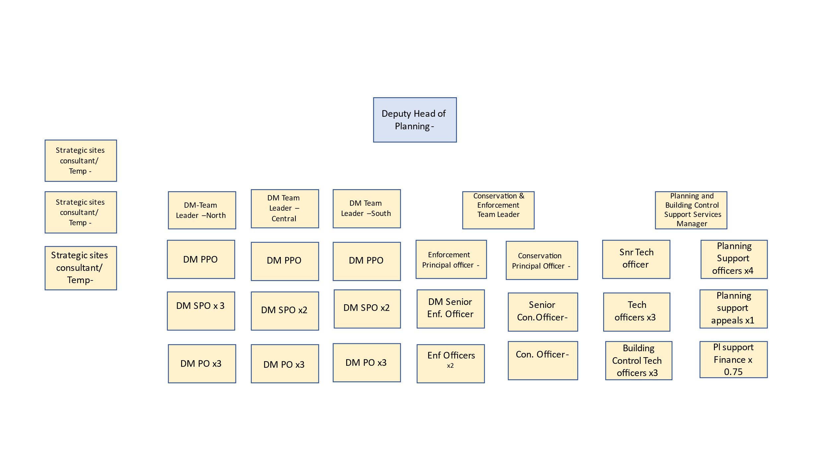

JOB ACCOUNTABILITIES
- Lead the DM Service, in consultation with the Assistant Director Place- Planning. Managing and taking responsibility for all aspects of the development management function including assessment, recommending and determining delegated planning applications, pre-application enquires, planning performance agreements, negotiating s106 agreements, planning appeals including public Inquires and enforcement.
- Advise the council, relevant committees, elected councillors and, as necessary, the public and other relevant bodies or groups on all matters relating to development management, enforcement and conservation.

- Manage the council’s response to planning appeal (Written Representations, Hearing and Public Inquiries) and when appropriate prepare the Council’s case and appear as the council’s expert witness.
- Exercise authority delegated to the post to determine planning applications, enforcement and other relevant matters. And manage and lead the delivery of robust and defensible planning decisions; enable and facilitate the delivery of development plan developments and strategic sites within the Borough to support the Council’s place- making, sustainability and quality agenda.
- Be responsible for building and maintaining positive relationships with internal and external stakeholders including MPs, Ward councillors, other service departments, developers, agents, applicants, statutory and non-statutory consultees and Town/Parish Councils.
- Advise and support the Enforcement and Conservations Team leader, provide appropriate advice on enforcement related decisions including expediency of action, formal and informal enforcement actions, and direct action. Ensure that Enforcement undertaken in accordance with the adopted enforcement plan and action taken where appropriate.
- Provide strong leadership to the Development Management Service by keeping staff motivated, providing regular case and performance review and feedback sessions, working with them to identify career development paths for staff and opportunities to broaden experience within the service, and manage poor performance.
- Oversee the development and management of planning performance agreements contributing to and agreeing cost estimates and realistic timelines and costs.
- Work with team leaders across the service functions to develop and embed a programme and project management approach.
- Positively engage with Planning policy and contribute to the formulation and development of planning policy.
- Manage the council’s reputation in regard to these service areas and advise on and promote a positive image of the Authority and all stakeholders.

- Responsible for the effective day to day management and financial and performance monitoring of any contracts in line with the requirements set out in Part 8A of the Council’s Constitution.

Standard accountabilities/responsibilities that apply to all council staff or specific groups are set out in the Employee Handbook, these include:
- Corporate management
- Information governance compliance
- Whistleblowing
- General Safeguarding Statement
- Project and work management
- Working in a team
- Risk management including Health & Safety
- Equality of Opportunity
- Our corporate values
- Budget management
- Specific responsibilities for those working in services for children or adults
- Specific responsibilities for managers

The hand book can be viewed here

.

Local operating procedures and specific activities/tasks will be supplied by the service.

Person specification

Key Criteria | Essential | Desirable | How assessed
Qualifications and training | Chartered Town Planner (Royal Town Planning Institute or equivalent)  Worked at management level in local authority | Management qualification | Application form
Job  Competence summary  (knowledge, skills, abilities, experience) | Demonstrate extensive experience in Development Management and an understanding of the role of DM in the achievement of wider council and community objectives  Significant experience of managing teams of planners and related staff  In depth Knowledge of Planning and relevant local authority legislation and policy  Highly developer negotiation and influencing skills  Significant Knowledge of Heritage legislation and policy  Demonstrate extensive experience of undertaking and managing appeals and enforcement work  Significant experience of proactively progressing planning applications for large / major schemes.  Significant experience of working effectively with members, stakeholders and customers  Significant experience of working in a political environment, regularly dealing with elected politicians and forming effective working relationships  Highly developed interpersonal skills especially influencing/persuasion/negotiation  High level presentation skills  Sound understanding of performance management  Significant experience of coaching/training/ development of staff  Professional gravitas to engender the confidence of lead Members/senior staff |  | Application/interview  Application/interview  Application/interview  Application/interview  Application/interview  Application/interview  Application/interview  Application/interview  Interview  Interview  Interview  Interview  Interview  Interview
Other requirements  (eg unsocial hours working, driving licence, fit to drive Council vehicle etc) | Sound IT skills  Evidence of self management  Commitment to equality of opportunity  Flexibility of approach to adjust to changing priorities  Full driving licence and vehicle available for work  Evening meetings |  | Application form  Application form/interview  Application form  Interview  Application form  Application form
Politically restricted post

Yes

DBS check

Not required

This post has been identified as customer facing in accordance with Part 7 of the Immigration Act 2016 and therefore the council’s English language fluency standard applies. | The ability to converse at ease with the public, answer questions and provide advice, including the use of specialist terminology relevant to the job role/profession and where necessary for an extended period of time. |  | The competent answering of interview questions in English.

